**Project Name:** EZ Trip (A Travel Management System)

**Course Name:** Information System Analysis and Design

**Course code:** CSE347

**Section:** 01

**Group: 02**

**Submission Date:** May 14, 2023

**Submitted To:**

Md. Mohsin Uddin

Senior Lecturer,

Department of Computer Science & Engineering

**Submitted By:**

* Md Tahsin

ID: 2020-2-60-112

* Navid Zaman

ID: 2020-2-60-044

* Kazi Ehsanul Haque

ID: 2020-2-60-143

**Introduction:**

The project we have designed is a travel management system. There are a lot of tourist spots in our country. That’s why a lot of tourists love to travel to those spots. So, our system’s goal is to ensure an easy and joyful journey for those tourists. Another goal of our system is to get customers for those hotels who registered in our system.

Our system is designed based on two motivations. One is for the users (Tourists), and the other is for customers (Travel agencies and Hotels).

**User side Motivation:**

People don’t want to travel to any unknown and unsafe place. Besides, many people don’t know every tourist spot in our country. Generally, tourists travel to some common tourist spots of our country, like Cox’s Bazar, Shitakundo, Sajek, Rangamati, Bandarban, etc. Besides, it’s also offering other countries too. There are a lot of beautiful tourist spots. So, our motivation is to suggest those spots and nearby hotels where they can stay. Besides, our motivation is to ensure a safe and hassle-less journey for us at a reasonable price.

**Customer side Motivation:**

There are a lot of travel agencies and hotels that started their business recently. Sometimes, it becomes difficult for them to get customers as they are new in this sector and there are already well-known travel agencies and hotels in their area. So, for them, our motivation is to manage customers and show their advertisements or offered packages to the user through our system. We only charge them if we can manage customers for them.

In this system, maintaining data consistency is challenging. Besides, ensuring safety and security for the user while traveling is also a major challenge for us. Maintaining users’ private data like phone numbers, account numbers are another major challenge in our system. Besides, maintaining contracts with travel agencies and hotels and validating their services is an important challenge for our system.

**Non-functional Requirements:**

**Product requirements:**

**Usability:** The system User Interface must be user-friendly and meaningful. Icons and hints should be relevant to the object.

**Performance and scalability:** Each page should load within 4 seconds and must

implement proper load balancer so that the system can handle 10,000 requests a

time.

**Portability and compatibility:** The system should be responsive, and it should be compatible with any browser and device.

**Reliability and maintainability:** The system should use a split component system. So that each component can be maintained easily.

**Security:** The system must ensure no backdoor or vulnerability.

          - Account creation: The system must store user information, login details

and must grant access to the account when users enter the correct username.

and password.

          - Password: The system should not allow a user to create an accountuntil the user creates a strong password.

**Organizational Requirements:** ItProvides critical information to all the teams, including development, operations, quality assurance (QA) and maintenance, ensuring the teams are in agreement.

**Software delivery requirements:**

  - The software team will deliver the security module (Sign in, Sign up,

logout) and landing page within a week.

  - The complete system must be delivered within a month.

**Software implementation requirements:**

   -The software team will deploy the system on the hosting site.

   -The software team will train the employees of the “EZ Trip”.

**Functional Requirements:**

  There will be 3 interfaces:

**i) User**: Who wants to travel / Who want to find a package

* Users can use hotel, and package services separately.
* Users must login to use all the features of the website.
* Users can explore all the services provided by the website.
* Users can cancel their package or plan.
* Users must login to purchase a plan.
* Every page, which will be accessible without signing in, contains only promotions and offers.
* Users have to login to access the full function of the pages.
* Payment method: online banking and mobile banking and card.
* Users can’t see all the details of the provided service without log in.
* Users can generate his travel report through the website.
* Users will have a travel cart.

**ii) Administrator:** Who will be in the charge of the website.

* Admin can add, delete, and modify all the provided services.
* Admin can access the entire database.
* Admin can delete user and agency profiles.
* Admin can change any package.
* Admin can see overall sales details.
* Admin can post their offers or packages.

**Descriptions of Functional Requirements:**

* **There will be a landing page.**

There must be a landing page containing a search bar where users can enter their destination, departure date and number of people traveling together. There will be different pages for each of the navigation options.

* **Navigation Bar**

There will be a navigation bar in the website, which will contain , dashboard, flight ,bus, train, hotel, holiday Packages, business options

* **Sign-in/Sign-Up/Log-out**

There will be two different login pages.

* **Registration Page**

There will be two user creation pages. One for users and other one for agencies. Users must provide all the necessary details. Email should be verified during form creation.

* **Tour packages**

There will be different tour packages. Some are fixed and some can be modified by users.

            There will be holiday packages.

* **Hotels**

Detailed information about hotels, including contact number and address should be provided of each hotel on the website.

**Tools & Technologies:**

• **Programming Language:** For this project we used **JavaScript** (node JS & express Js) as backend and frontend programming language. Which responses fast, easy Scalability, compatible with all environments (windows, mac, Linux) and another reason of choosing JavaScript it’s cost effective and high performance for all modern applications.

 • **Database:** For this project we will use **MongoDB** as a database because of its data protection. It is one of the most popular database management systems in terms of security and dependability and we can scale our system with MongoDB. It’s highly efficient and 24/7 uptime.

 • **Frameworks:**

-In the frontend we have used **React JS** and for backend we have used **Node JS & Express JS**. The reason behind choosing React JS is the option to reuse development components. So, we can reuse our components and can save our development time. With that we can easily change a component within a short time. We will get more optimized applications and another advantage of React JS, it’s big community support.

-Moreover, we will use **Bootstrap**, which is a CSS framework. It offers more control over styling to the developers. This not only improves development speed but also improves productivity. If we compare this framework with the most popular CSS frameworks where Bootstrap is famous for responsiveness.

-For UI/UX design, we will use **Figma** software

**Use Case Diagram:**

34  
  
  
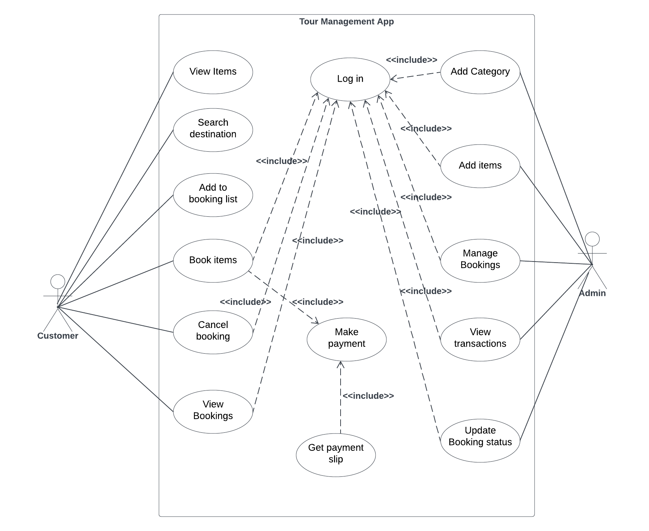

**Class Diagram:**

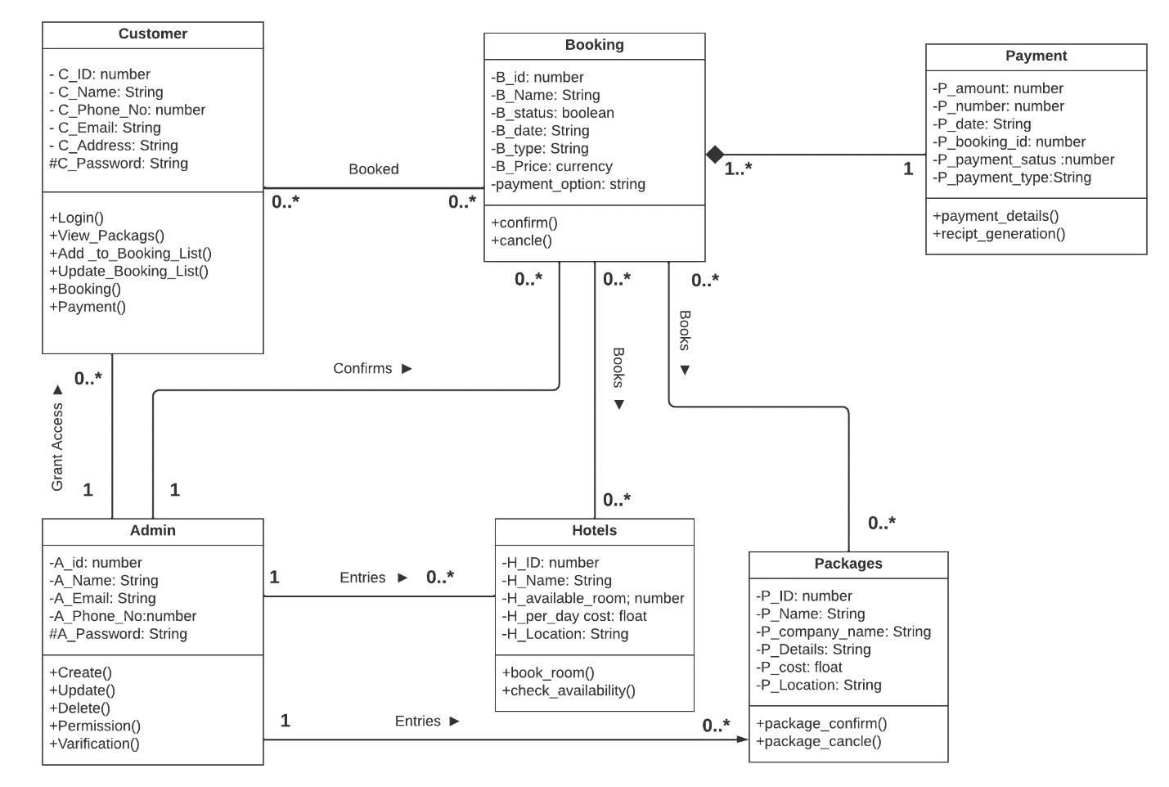

**Sequence Diagram:**

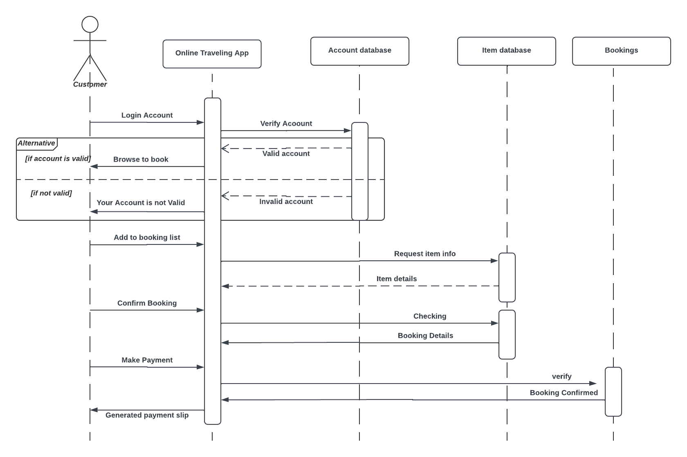

**Activity Diagram:**

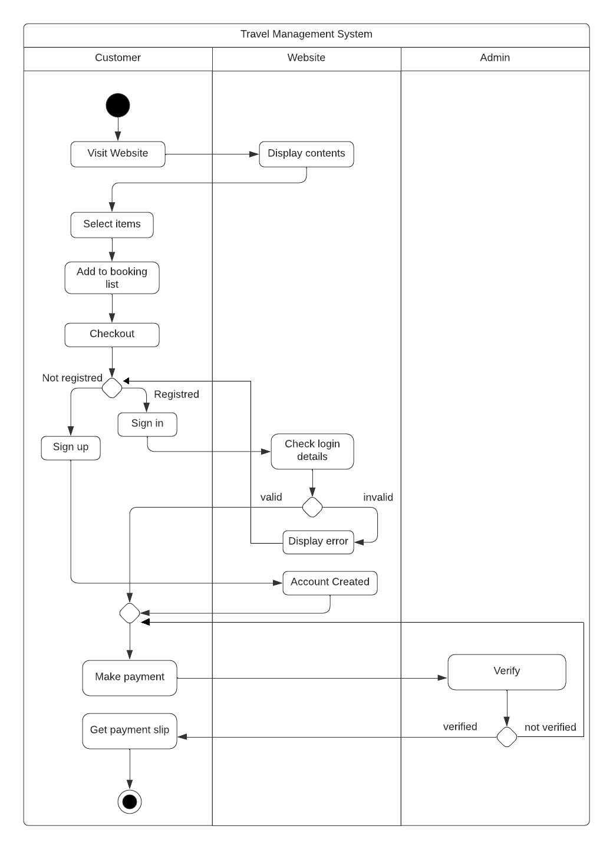

**ER Diagram:**





**GUI Screenshots:**



